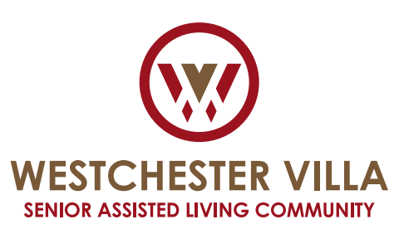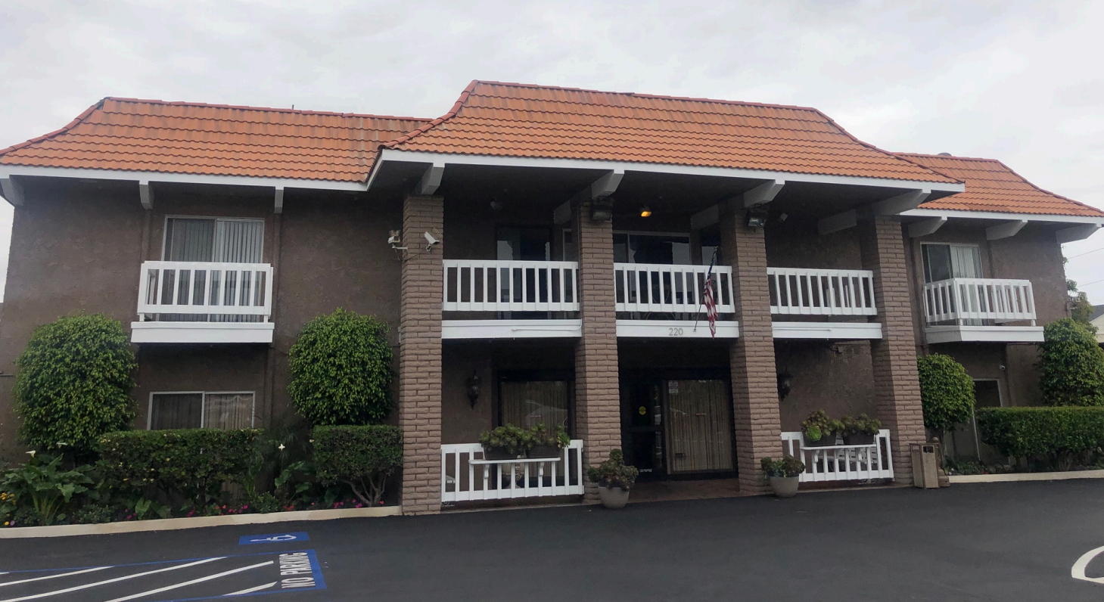
Residential & Memory Care Facility
Amenities and Accommodations:

- Furnished Rooms
- Daily Housekeeping Services
- Utilities except telephone
- Formal Restaurant Style Dining Room
- Courtyard and Gardens
- Social Activity Program
- Lounges, Library
- Television Center & Beauty Salon
- 24 Hour Staff Caring
- Medication Management
- Chauffeured Transportation within 7 miles of community

Provider of Contracted with (required enrollment or approval):

- Medi-Cal ALWP (Assisted Living Waiver Program)
- DHS Housing for Health – ERC
- Veterans Affairs
- Blue Cross Anthem
- Calpers Insurance

LIC # 198205637
220 W Manchester Blvd, Inglewood, CA 90301
Tel # (310) 673-1093
www.westchestervilla.com

